# CHAPTER III ONU WIFI SETTING

## General Theory

### **Augmented Reality**

Optical fiber communication system is a communication system that uses fiber optic cable as a transmission line that can channel information with large capacity and high concentration. Different from other transmission media, fiber optic does not use electric wave as its transmission wave but use light wave.

Fiber To The Home (abbreviated as FTTH) is the implementation of network with fiber optic cable delivery medium to reach to customer point (customer premise). The development of this technology is inseparable from the advancement of the development of optical fiber technology that can replace the conventional cable in the form of copper cable (Cu). And also driven by the desire to get a service known as Triple Play Services is a service will be fast internet access, voice (telephone) and video (Cable TV) in one infrastructure on the customer unit.

In the provision or distribution of triple play services or even two play services there are various kinds of tools for channeling networks that have been channeled through fiber optic cables. one of them is a device called Onu.

### **Advantages and Disadvantages of Using Fiber Optic**

1. **Advantages**
   * + 1. Fiber optics is able to distribute more data at high speeds, even reaching Gbps, so the bandwidth becomes larger.
       2. Has a slight disruption, because the optical fiber is not affected by electromagnetic and radio signals because it does not use electricity but uses plastic and light.
       3. More secure, because the optical fiber is not flammable and does not generate electricity at all.
       4. Fiber optic network cables can transmit even better signals, even without signal amplifier devices such as repeaters or other. Even if needed, the signal booster does not need to be installed every 5 km like other network cables, just enough every 20 km only.
2. **Disadvantages**
   * + 1. The installation process of the fiber optic network cable still requires some special tools and materials so it costs more expensive than other types of network cable.
       2. Fiber optic can not be mounted on an area with 45 degrees or less. For transmission using light, and the curves are too sharp can result in leakage of optical fiber and collect light on the area of ​​the curve.
       3. If damaged, then to repair the fiber-optic network cable requires skilled personnel in this field

## B.Working Procedure

**1.** **Item and tool requirement for setting Onu**

Before setting , we need to bring the items and tools as follows:

a)Item

Table 3.1 Item Requirement

|  |  |  |  |
| --- | --- | --- | --- |
| **No** | **Item** | **Qty** | **Picture** |
| 1 | Onu | 1 pcs | Picture 3.1 Onu |

b )Tool

Table 3.2 Tool Requirement

|  |  |  |
| --- | --- | --- |
| **No** | **Tool** | **Picture** |
| 1 | Laptop | Picture 3.2 Laptop |

**2.****Onu Setting**

1. Installation of ONU / Router
2. Install the ONU / Router adapter in the electrical socket.
3. Plug the end of the adapter in the ONU / Router adapter port.
4. Install the pigtails that are mounted on ONU.

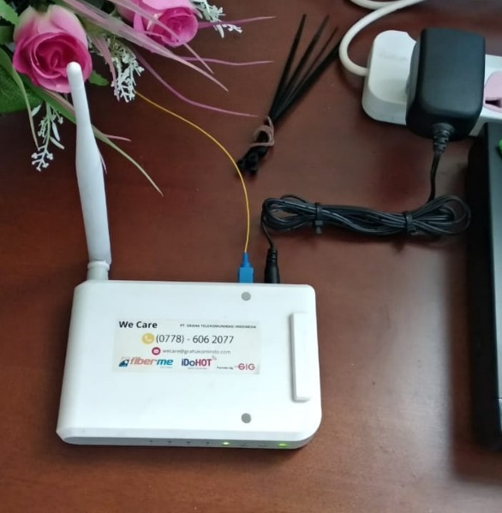

Picture 3.3 Installation ONU

1. Look for the SSID Onu

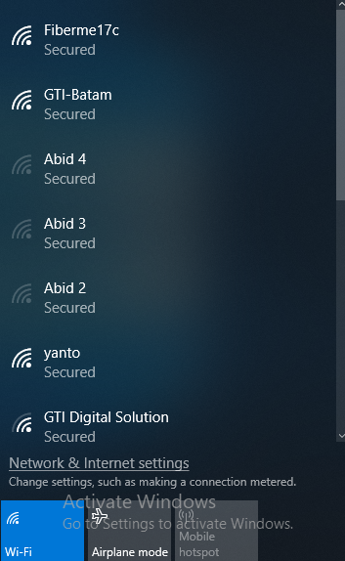

Picture 3.4 Ssid Of the Onu

1. Send ONU MAC photos to the network admin to get IP address.

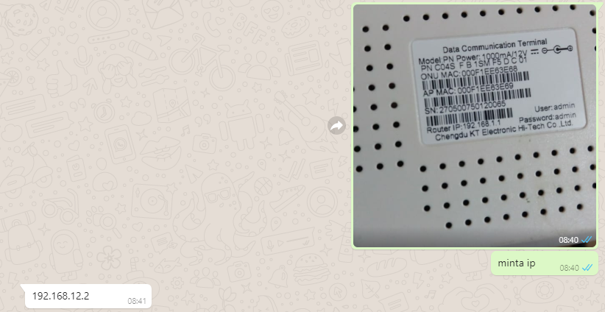

Picture 3.5 Sending MAC

1. Setting up the Onu
2. Plug the Onu Adapter in the power outlet.
3. After life make sure the Onu in the state has not been set. If there is a setting then we can reset by long pressing the black button on the back of the Onu.
4. Then plug the LAN from the laptop into the LAN Onu port, or it could by entering the Onu wifi.
5. Access the Onu by going to the web browser and entering the 192.168.1.1 address.



Picture 3.6 Onu Address

1. Fill **username: admin, password: admin** appears below.

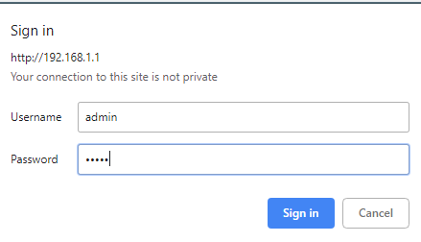

Picture 3.7 Login Onu

1. Initial display on onu settings

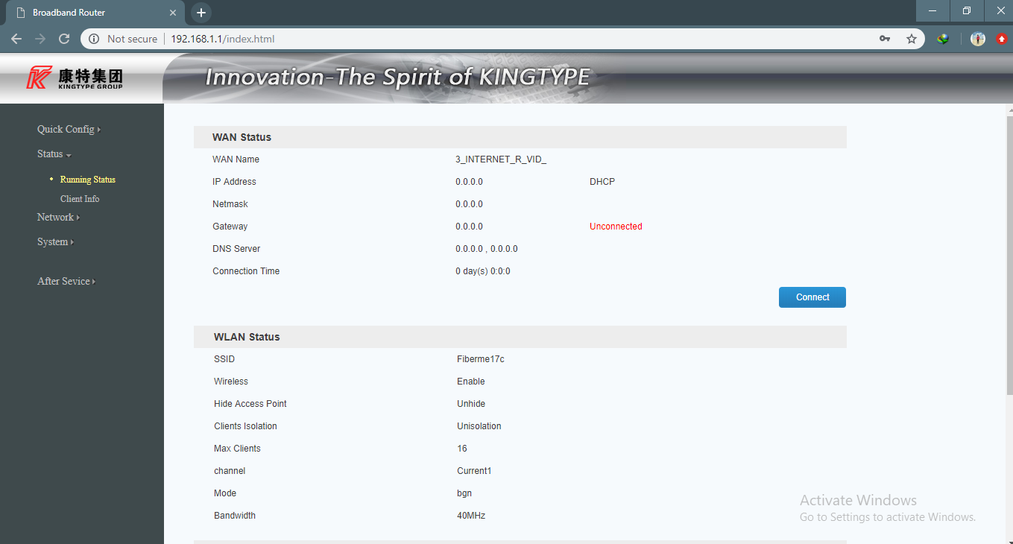

Picture 3.8 Display onu Setting

1. Then setting the wan method is changed to static, then set ip that has been given admin, then subnet mask, and gateway, if it has changed the dns

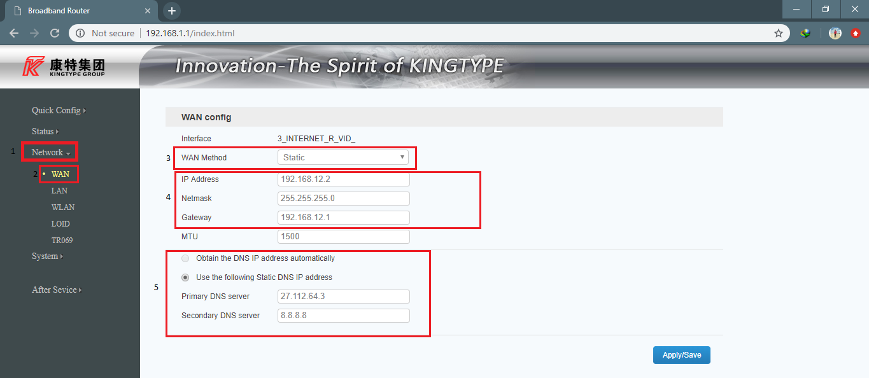

Picture 3.9 Setting Network

1. Enter the channel settings and change the channel to channel 1

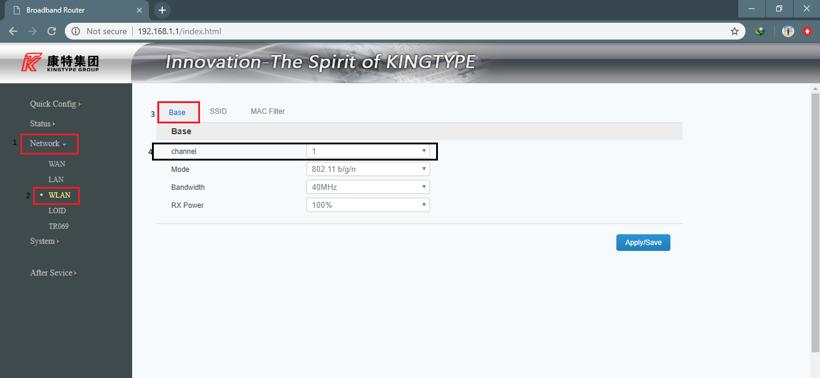

Picture 3.10 Setting Channel

1. Replace SSID and password, to maintain the privacy of the customer Then **Save.** (**Note:** Answer the customer by the name of WI-FI and password)

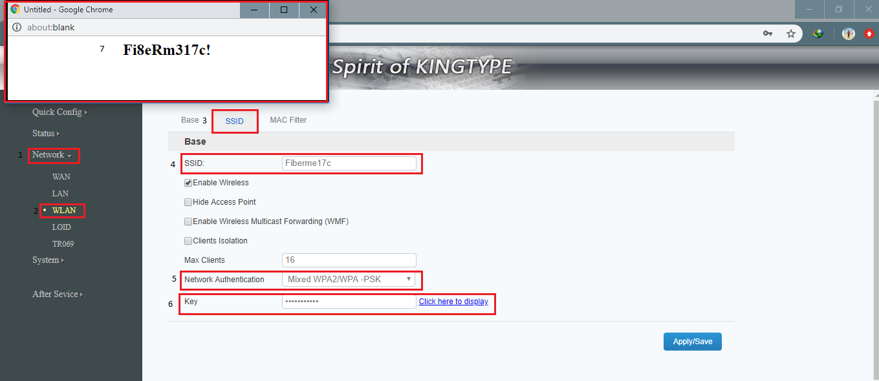

Picture 3.11 Setting Wireless SSID

1. Then fill in the new **Username & Password**.



Picture 3.12 Login back

1. After reboot finish, do **Speedtest**.



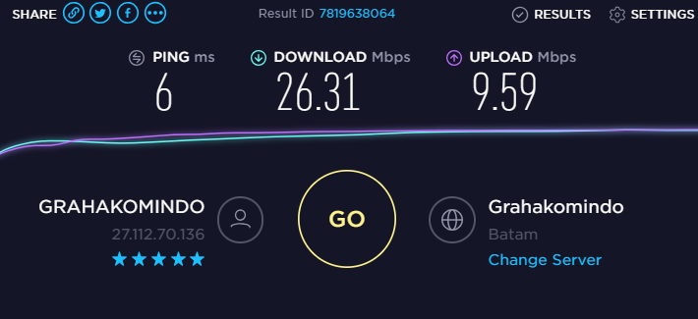

Picture 3.13 Speedtest

### **3.****Problems on the Onu Setting and problem solving**

These are some problems found on the Onu setting and the problem

solving:

* + - 1. The db signal is decreased / lost which causes internet loss.
         1. Cause : Cable is broken, Cable is twisted
         2. Problem solving :

a) Check the splice in rosette or ODP

b) Tidying the cable

c) Re-splacing

* + - 1. The db signal is OK but the internet but the internet is still disconnected / loss.
         1. Cause : ONU or router are damaged, error setting
         2. Problem solving :

a) Restart ONU or router

b) Check router setting

c) If the router setting is good but the internet diconnected, change the old ONU with new ONU.

* + - 1. The internet is still slow.
         1. Cause : the DB signal is decreased, error setting
         2. Problem solving :

a) Check the DB

b) Restart ONU or router

c) Check the router setting

* + - 1. The WI-FI SSID often disappears
         1. Cause : Cable is broken, Cable is twisted
         2. Problem solving :

a) Restart the router

b) Check the router setting

c) Change with new router

* + - 1. The router settings is reset
         1. Cause : Unintentional from customers
         2. Problem solving :

1. Reset the router setting

hubungan antara fiber optik dengan onu adalah dimana fiber optic sebagai pemberi sinyal atau pemberi jalur internet ke onu,maka dari itu saya membuat judul saya onu wifi setting dan background pemilihan judulnya fiber optic

the connection between fiber optic and onu is where the fiber optic is the signal giver or the internet lane provider to onu, so I made my title onu wifi setting and the background for choosing the title is fiber optic